Lexington Survey Results

Overall Satisfaction: 75.4%

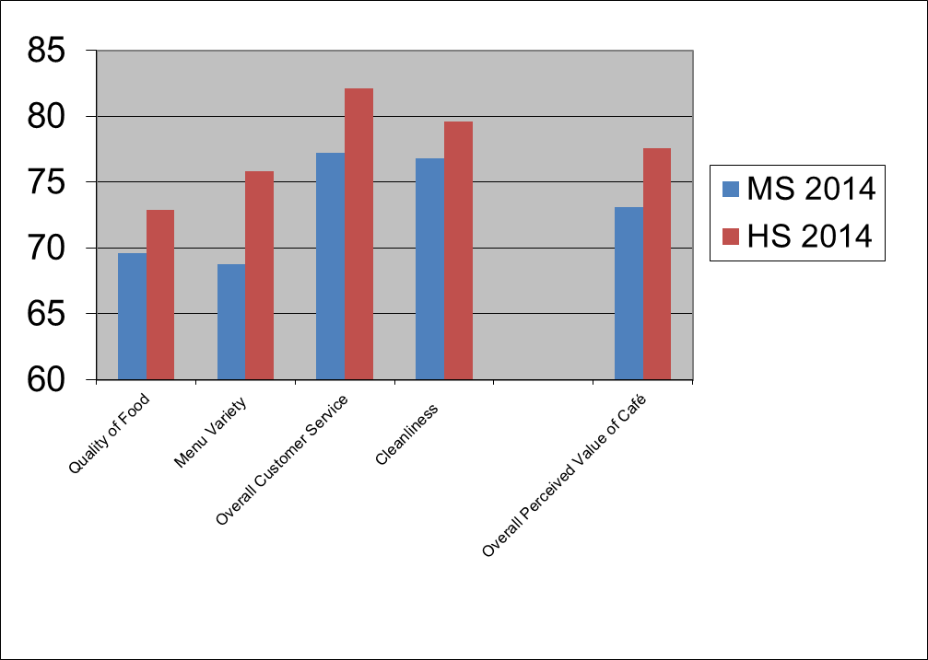

# responses: 572

Lexington 2014 Survey Results

Please share any comments or suggestions you may have about the school nutrition program:

The most common comments and concerns included:

- Love the always-open line
- Food is great; an improvement over last provider
- Would like healthier choices and fresher food
- Healthy choices have improved, but has reduced variety
- Too many healthy choices/don’t like whole wheat
- Would like more vegetarian options
- Sandwich bar is popular
- Needs more variety –gluten free, ethnic options, breakfast wraps, dairy-free options, healthier snacks
- Portion sizes are too small
- Lines are too long/wait too long
- My child is dissatisfied with the quality and taste, i.e. pizza, vegetables
- Breakfast options need improvement

