To: Dr. Paul B. Ash,
Superintendent of Schools

From: Tom Plati,
Director of Educational Technology and Assessment

Re: Town Meeting Member Request for Information on Article 13 on
School Technology

Date: March 13, 2013

The purpose of this memo is to address Andrei Radulescu-Banu’s (Pct. 8) request for additional background information on the $224,000 of the technology capital request for the purchase of interactive projector/whiteboard units for our Grades 3-12 classrooms. This purchase would represent the second stage of a plan to equip all Grade 3-12 classrooms with such technology. This appropriation would allow for the purchase and installation of 70-72 units. This will leave approximately 90 Grade 3-12 classrooms to equip in a third phase in FY15. The current appropriation would be used to equip 28 high school classrooms, 26 middle school classrooms, and 18 in classrooms in five elementary schools (all but Estabrook School, which is being funded through the building project).

The 65 units installed during the current 2012-13 year and those planned on being installed in FY14 are different from those units installed in all earlier years. We are purchasing SMART LightRaise Interactive Projectors. The interactive technology with the units resides in the projector and will allow teachers and students to use a SMART pen or their own fingers to use all of the SMART interactive features. We also will be purchasing low-gloss porcelain enamel steel marker whiteboards to replace existing whiteboards. The new whiteboards can be written on with normal dry erase markers as well as be used interactively with the SMART technology. The whiteboards are replacing boards that for the most part are 12 years or older and made of materials that did not stand up to the dry erase marker use over time. The low-gloss finish of the boards allow for excellent projection viewing. The projectors and whiteboards will not be replaced every 3-4 years. The new whiteboards and writing surfaces are guaranteed for the life of the building. I anticipate that given normal use we will be replacing the SMART LightRaise projector lamps (about $175) out of operating budget every 3 years. The SMART LighRaise projectors themselves should run 7-8 years under normal conditions.

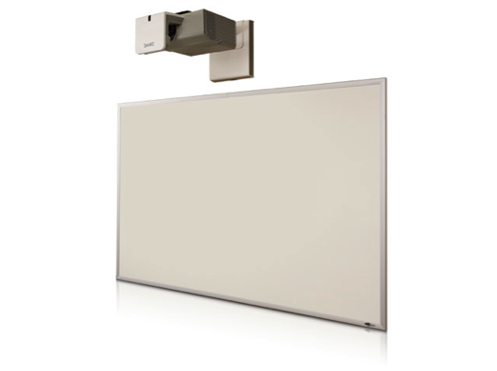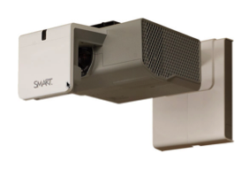
Porcelain enamel steel marker whiteboard (can be written with dry erase marker or used with interactive SMART technology
SMART LightRaise projector

Interactive projector/whiteboard units are extremely important tools for teachers in providing academic instruction. The Lexington Public Schools has emphasized this on-going training and coaching with the SMART installations.

Lexington teachers our using the interactive projector/whiteboard technology very successfully in all the different academic settings from upper elementary grades through high school grades to engage students and to provide our students with a better understanding of curriculum concepts. Our teachers have also had very positive results utilizing the SMART technology in our classrooms with youngsters with learning disabilities. As noted in my School Committee presentations at previous meetings, a number of other school districts we compare ourselves already have such interactive technology substantially in place (e.g. Concord Carlisle 100%, Wellesley 95%, Sudbury 100%, Weston 70%. By June of this year, we will have around 50% of our classrooms of our Grades 3-12 classrooms with this technology.

